Youaregivenatwo-dimensional3\*3arraystartingfromA[0][0].Youshouldaddthe alternateelementsofthearray

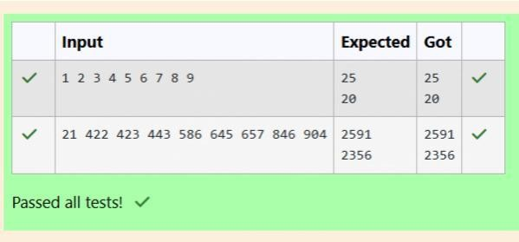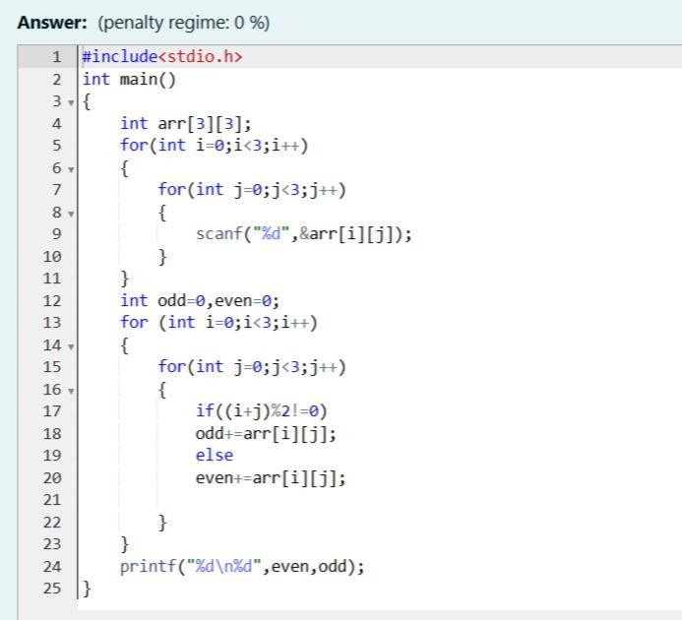

Andprintitssum.ItshouldprinttwodifferentnumbersthefirstbeingsumofA00,A02,A 11,A20,A22andA01,

A10,A12,A21.

InputFormat

Firstandonlylinecontainsthevalueofarrayseparatedbysinglespace Outputformat

FirstlineshouldprintsumofA00,A02,A11,A20,A22

SecondlineshouldprintsumofA01,A10,A12,A21



ShyamLal,awealthylandlordfromthestateofRajasthan,beinganoldfellowandtiredof doinghardwork,decidedto

Sellallhisfarmlandandtoliverestofhislifewiththatmoney.Nootherfarmerisrich enoughtobuyallhislandsoheDecidedtopartitionthelandintorectangularplotsof

differentsizeswithdifferentcostperunitarea.So,hesoldthesePlotstothefarmersbut madeamistake.Beingilliterate,hemadepartitionsthatcouldbeoverlapping.Whenthe Farmerscametoknowaboutit,theyrantohimforcompensationofextramoneytheypaid tohim.So,hedecidedtoReturnallthemoneytothefarmersofthatlandwhichwas overlappingwithotherfarmer’slandtosettledowntheConflict.Alltheportionofconflicted landwillbetakenbackbythelandlord.Todecidethetotalcompensation,hehasto calculatethetotalamountofmoneytoreturnbacktofarmerswiththeSamecosttheyhad purchasedfromhim.Suppose,ShyamLalhasatotallandareaof1000x1000equalsquare blocksWhereeachblockisequivalenttoaunitsquareareawhichcanberepresentedon theco-ordinateaxis.NowfindtheTotalamountofmoney,hehastoreturntothefarmers.

HelpShyamLaltoaccomplishthistask.

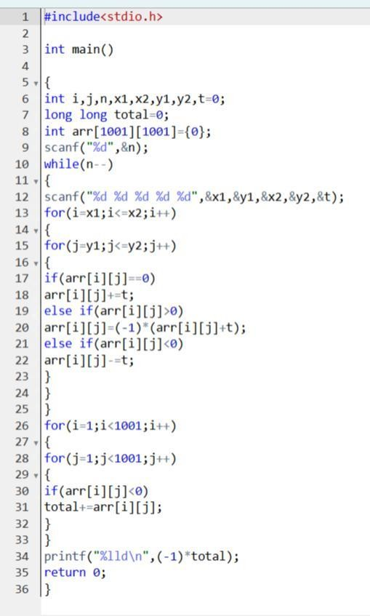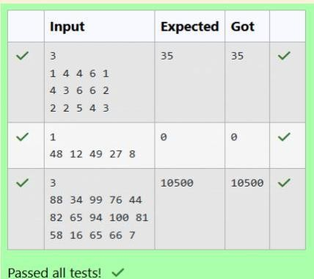

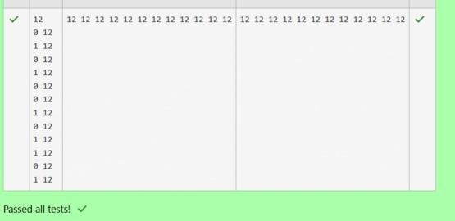Microsofthascometohireinternsfromyourcollege.Nstudentsgotshortlistedoutof whichfewweremalesandafewFemales.Allthestudentshavebeenassignedtalent levels.Smallerthetalentlevel,lesserisyourchancetobeselected.Microsoftwantsto createtheresultlistwhereitwantsthecandidatessortedaccordingtotheirtalentlevels,

butthereIsacatch.ThistimeMicrosoftwantstohirefemalecandidatesfirstandthenmale candidates.Thetaskistocreatealistwherefirstall-femalecandidatesaresortedina

descendingorderandthenmalecandidatesAresortedinadescendingorder. InputFormat

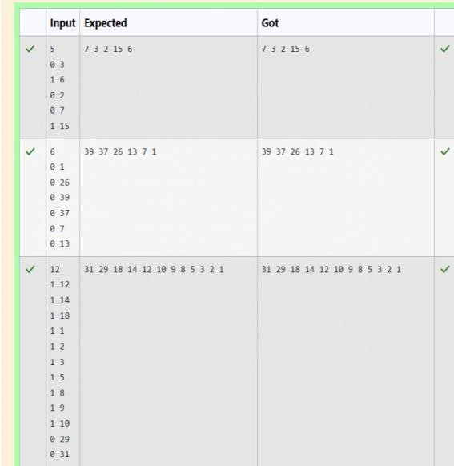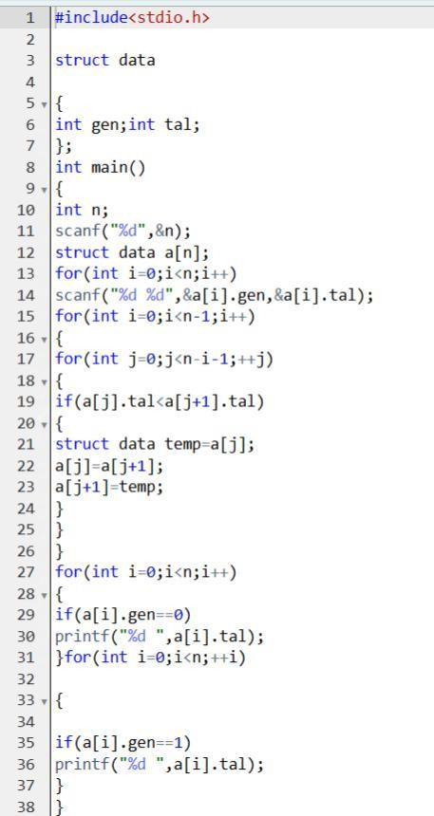ThefirstlinecontainsanintegerNdenotingthenumberofstudents.Next,Nlinescontain twospace-separatedIntegers,aiandbi.Thefirstinteger,aiwillbeeither1(foramale candidate)or0(forfemalecandidate)Thesecondinteger,biwillbethecandidate’stalent level.